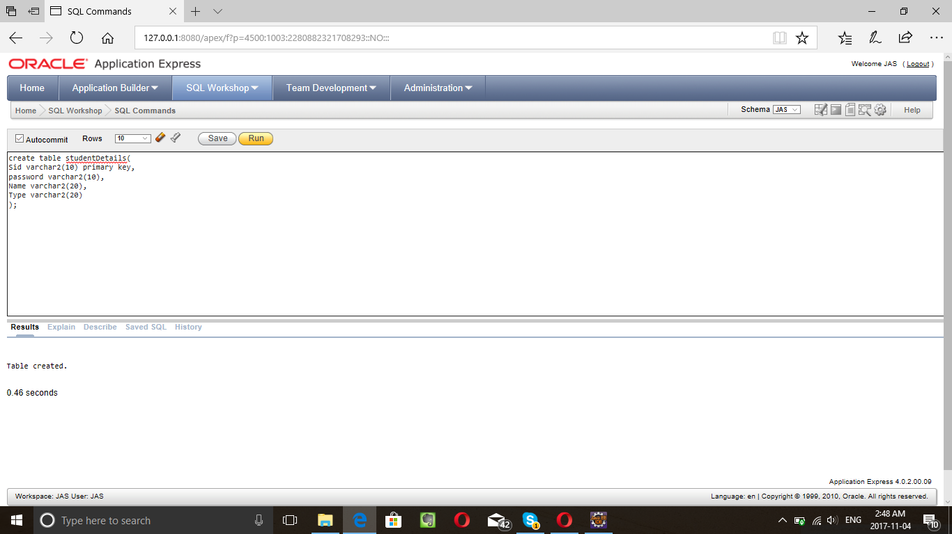

create table studentDetails(

Sid varchar2(10) primary key,

password varchar2(10),

Name varchar2(20),

Type varchar2(20)

);

Insert into studentDetails(

Sid, Password, Name, Type) values ('40014728', '123', 'Jaspreet', 'International');

Insert into studentDetails(

Sid, Password, Name, Type) values ('40014729', '123', 'Pardeep', 'Canadian');

Insert into studentDetails(

Sid, Password, Name, Type) values ('40014727', '1234', 'James', 'Quebecois');

create table AdminDetails(

Adminid varchar2(10) primary key,

password varchar2(10)

);

Insert into AdminDetails(

Adminid, Password) values ('admin', '123');

create table facultyDetails(

id varchar2(10) primary key,

password varchar2(10),

name varchar2(15)

);

Insert into facultyDetails(

id, Password, name) values ('prof1', '123','Dr.Joey');

create table DirectorDetails(

id varchar2(10) primary key,

password varchar2(10)

);

Insert into DirectorDetails(

id, Password) values ('abc', '123');

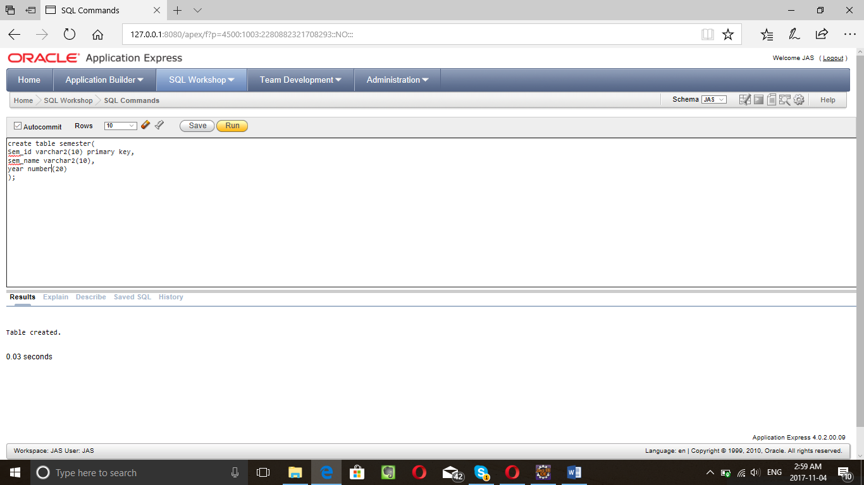

create table semester(

Sem_id varchar2(10) primary key,

sem_name varchar2(10),

year number(20)

);

insert into semester(Sem_id ,sem_name, year) values(1, 'Fall',2017);

insert into semester(Sem_id ,sem_name, year) values(2, 'Winter',2018);

insert into semester(Sem_id ,sem_name, year) values(3, 'Summer1',2018);

insert into semester(Sem_id ,sem_name, year) values(4, 'Summer2',2018);

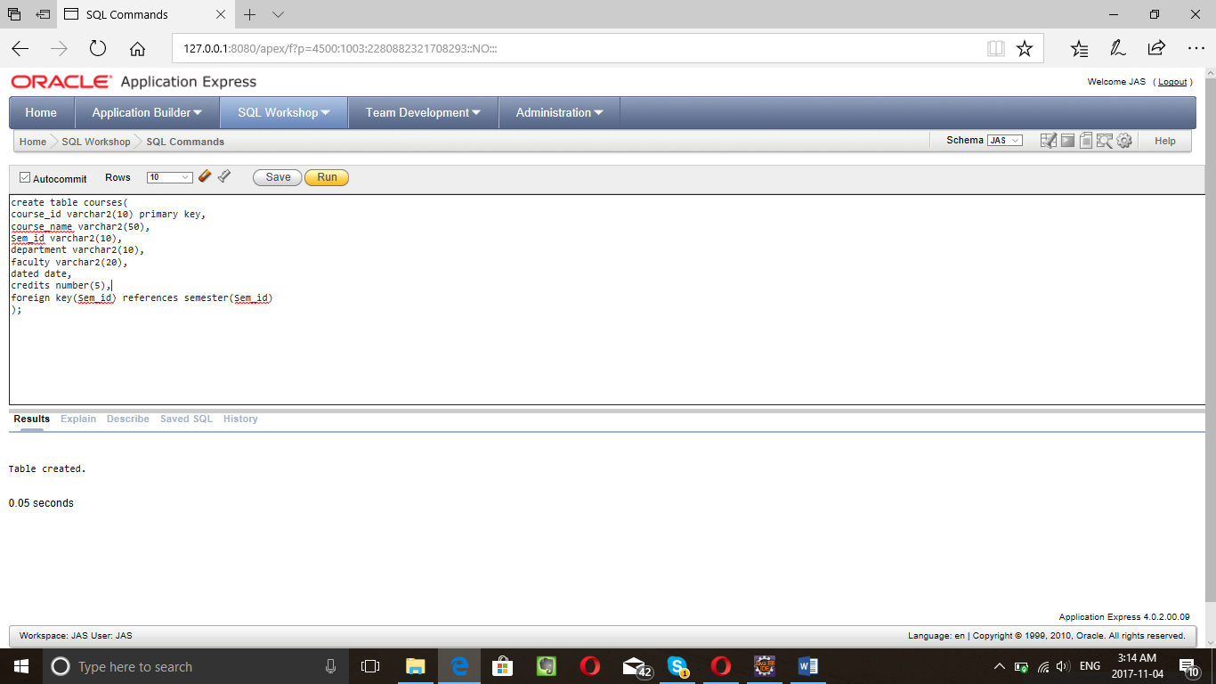

create table courses(

course_id varchar2(10) primary key,

course_name varchar2(50),

Sem_id varchar2(10),

department varchar2(10),

faculty varchar2(20),

dated date,

credits number(5),

foreign key(Sem_id) references semester(Sem_id)

);

insert into courses(course_id ,course_name ,Sem_id, department, faculty, dated, credits) values('INSE6260', 'Software Quality Assurance','1','INSE','Dr. Rachida',to_date('20170903','YYYYMMDD'),4);

insert into courses(course_id ,course_name ,Sem_id, department, faculty, dated, credits) values('SOEN6441', 'Advanced Prog. Practices','1','SOEN','Dr. Joey',to_date('20170903','YYYYMMDD'),4);

insert into courses(course_id ,course_name ,Sem_id, department, faculty, dated, credits) values('SOEN6421', 'Advanced Database','1','SOEN','Dr. Joey',to_date('20170903','YYYYMMDD'),4);

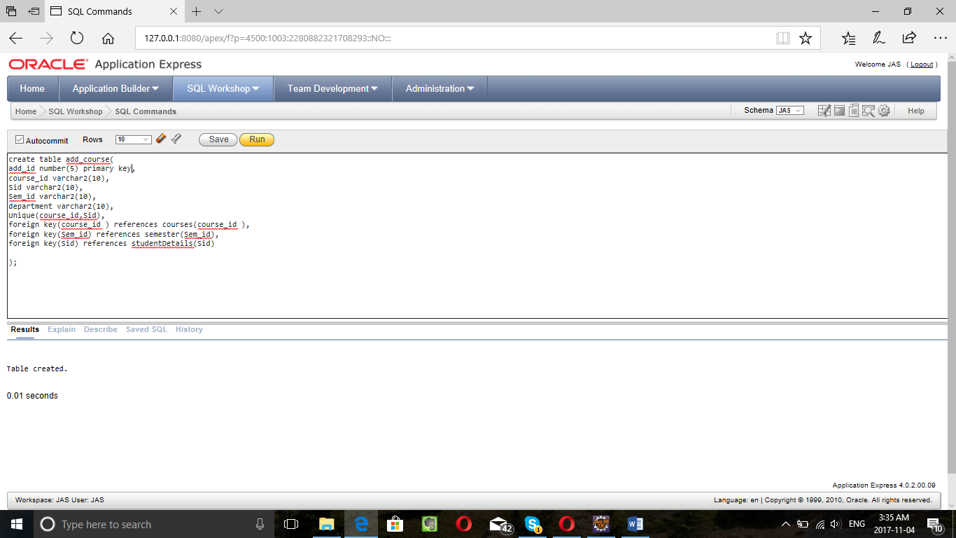

create table add_course(

add_id number(5) primary key,

course_id varchar2(10),

Sid varchar2(10),

Sem_id varchar2(10),

department varchar2(10),

Unique(course_id,Sid),

foreign key(course_id ) references courses(course_id ),

foreign key(Sem_id) references semester(Sem_id),

foreign key(Sid) references studentDetails(Sid)

);

insert into add_course(add_id, course_id, Sid, Sem_id,department) values(1,'INSE6260','40014728',1,'INSE');

insert into add_course(add_id, course_id, Sid, Sem_id,department) values(2,'SOEN6441','40014728',1,'SOEN');

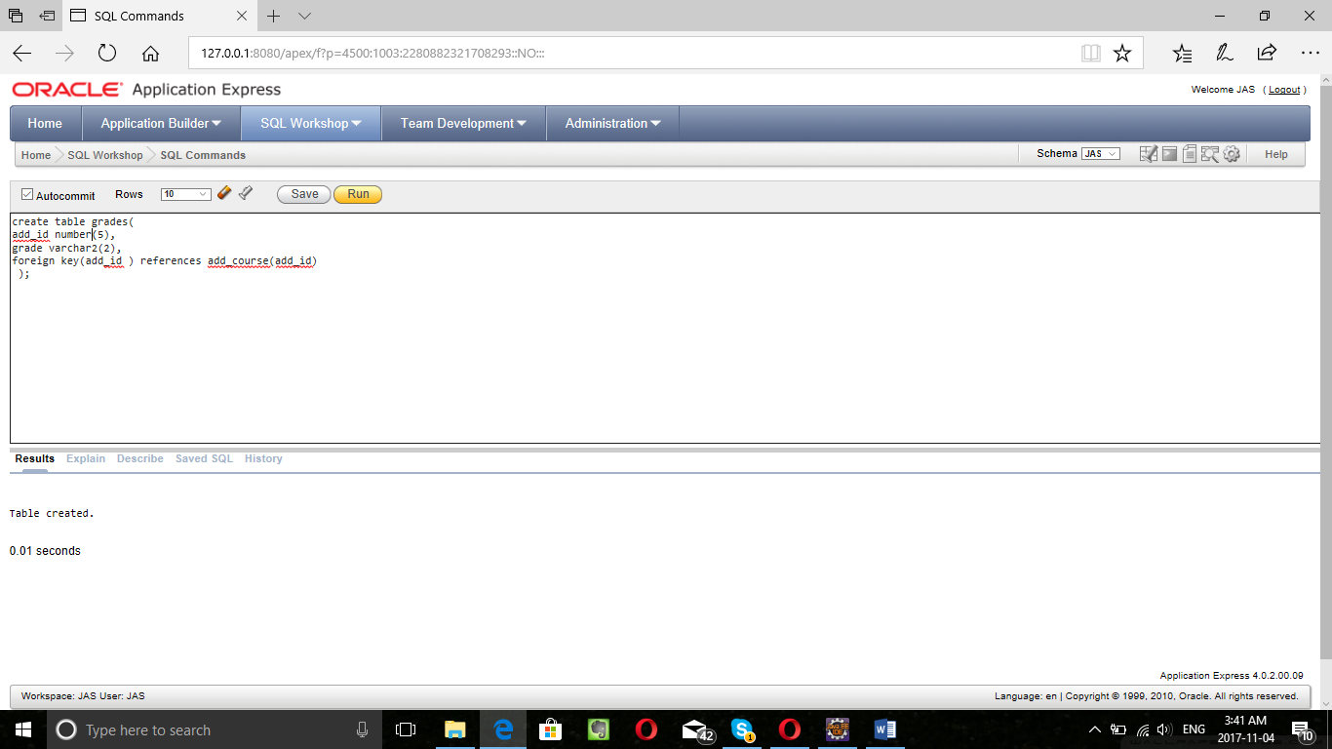

create table grades(

add_id number(5),

grade varchar2(2),

numeric_grade number(3,2),

foreign key(add_id ) references add_course(add_id)

);

alter table grades add

(numeric_grade number(3,2));

insert into grades(add_id, grade) values(1,'A+');

insert into grades(add_id, grade, numeric_grade) values(1,'A+', 4.3);

insert into grades(add_id, grade, numeric_grade) values(2,'A', 4.0);

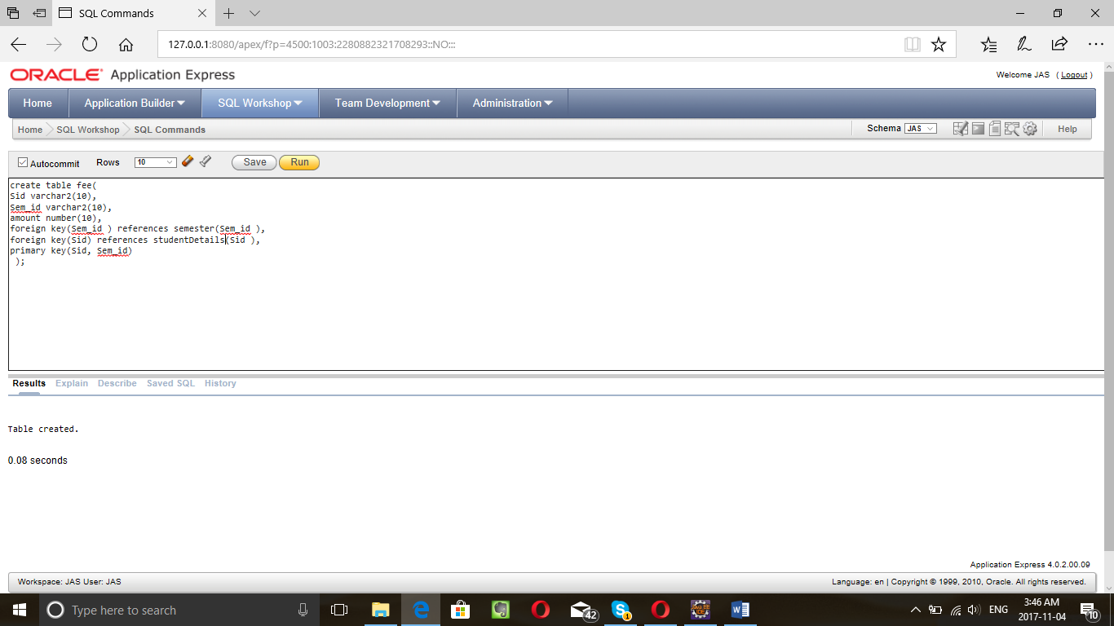

create table fee(

Sid varchar2(10),

Sem_id varchar2(10),

amount number(10),

foreign key(Sem_id ) references semester(Sem_id ),

foreign key(Sid) references studentDetails(Sid ),

primary key(Sid, Sem_id)

);

Insert into fee(Sid, Sem_id, amount) values('40014728','1',6000);

update fee set amount=6500 where Sid='40014728' and sem_id=1;

Select S.Sid, S.Name, S.Type, A.course_id, A.Sem_id , g.grade from studentDetails S, add_course A, grades g where S.Sid=A.Sid and A.add_id=g.add_id;

create table studentDept(

Sid varchar2(10),

department varchar2(10),

foreign key(Sid) references studentDetails(Sid) );

insert into studentDept(Sid, department) values('40014728','SOEN');